**Content Approval workflow with OR Split and Branches**

Requirement:

***We need to start the workflow for our workflow model activation ,If the workflow starts from US related page it need to go the ‘Us apporvel process’ ,If the workflow starts from IN related page it need to go the ‘IN apporvel process’ , if we don’t get the data from both the countries it will need to go the ‘others apporvel process’.For ‘US’ one approvel step needed and For ‘india’ two apporvel steps needed and for ‘others’ no approvel step needed .***

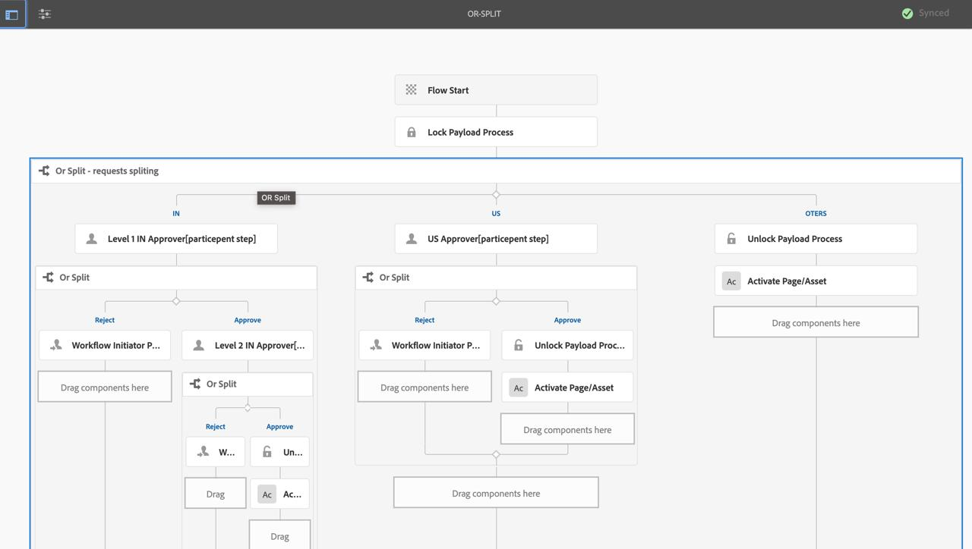

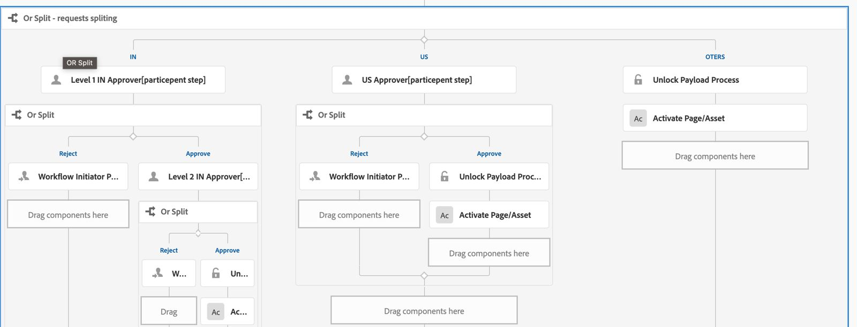

**unlock payload process workflow step usage:**

The "Unlock Payload Process" in an Adobe Experience Manager (AEM) workflow is the counterpart to the "Lock Payload Process." Its primary purpose is to unlock a previously locked resource (payload) so that it can be accessed and modified by other users or processes

**OR Split workflow step usage:**

In Adobe Experience Manager (AEM), the "OR Split" workflow step is used to create a conditional branching point within a workflow. It allows the workflow to follow different paths based on specified conditions.

**Workflow Initiator Participant Chooser :**

In Adobe Experience Manager (AEM), the "Workflow Initiator Participant Chooser" is a workflow step that allows the initiator of the workflow to select participants (users or groups) dynamically. This step is useful for workflows that require human intervention or approval from specific individuals or groups

**Activate Page/Asset Process - Step Properties:**

The "Activate Page/Asset Process" step in Adobe Experience Manager (AEM) is used within workflows to publish (activate) pages or assets. This step automates the activation process, ensuring that the specified content is made available on the publish instance. This is particularly useful in content approval workflows where, once approved, content needs to be automatically published.



***Flow of The code :***

***1🡪First we start the workflow by choosing some page for example I will choose india***

***2🡪It go to the Lock Payload process step and lock the content***

***3🡪Then Move to the ORSPLIT , In the orsplite we have 3 branches IN,US,OTHERS***

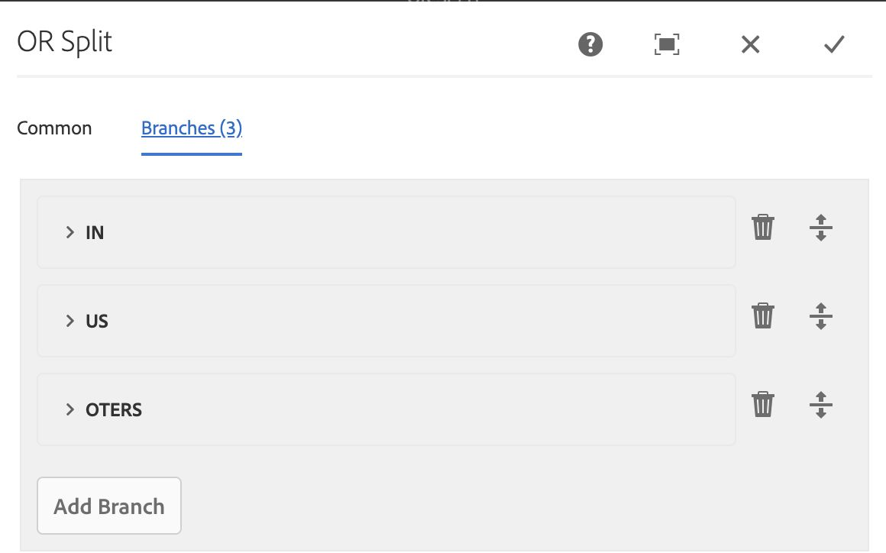

***4🡪In the every branch we write ECMA script to identifie the page realted to which country***

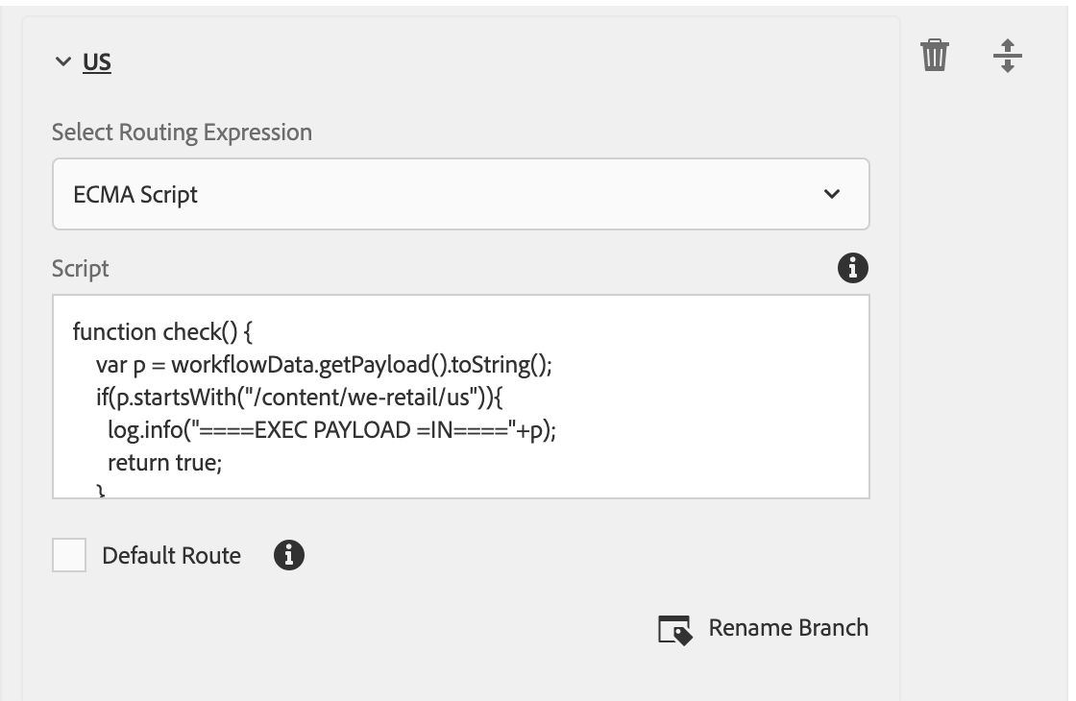

***5🡪Here we are sending IN county page by using ecma script it will go to the Level 1 IN Approver [paricipent step] , In the particepent step we have a user ,It will go that user once we start the workflow***

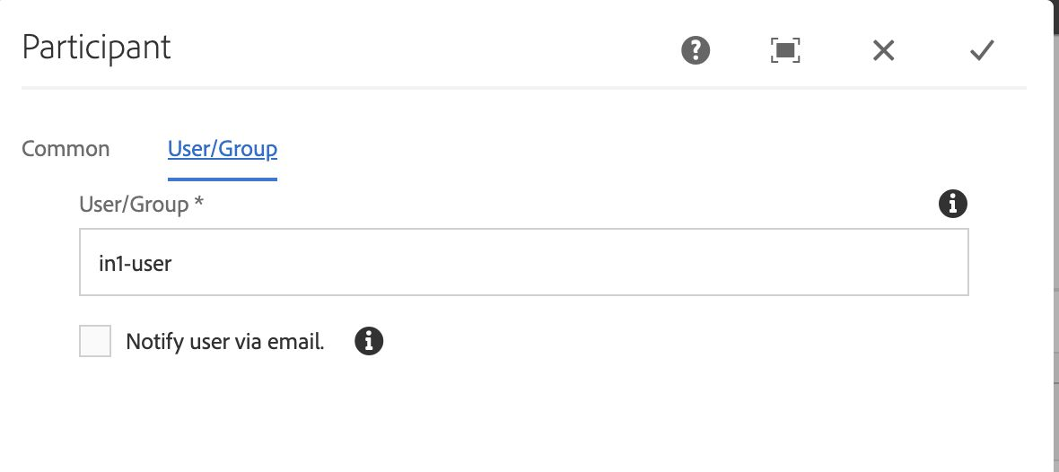

***6🡪we can check the workflow process in the INSTANCE***

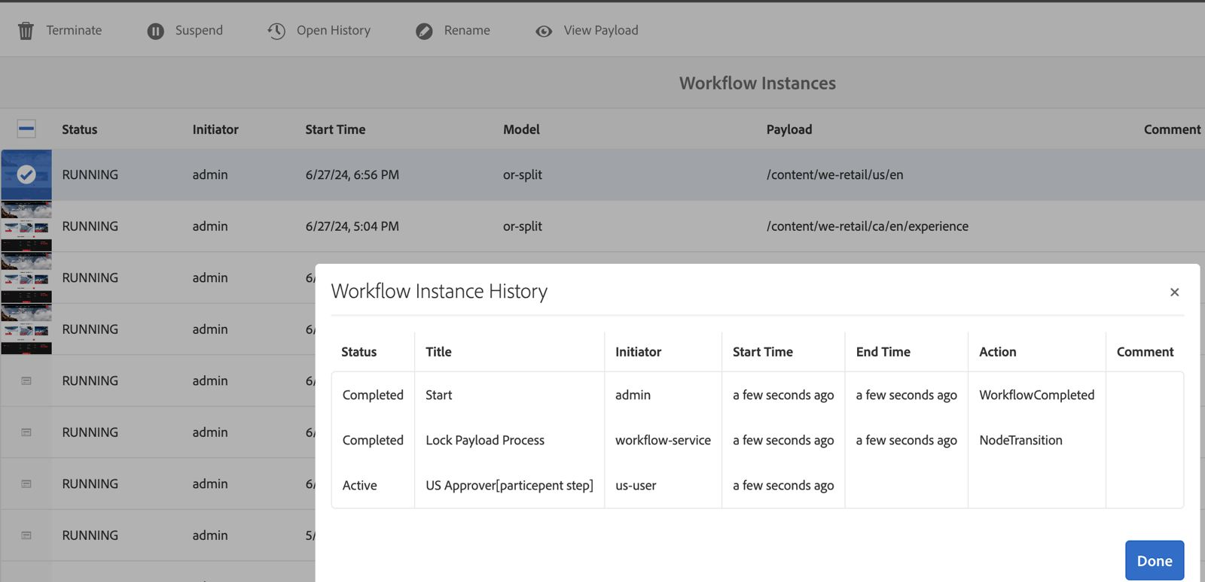

***7🡪Once we start the workflow it will go the user and next step is to login to that user and complete the workflow when we are clicking the complete option we will get one popup option this option is useful for select the next workflow process either agree or reject***

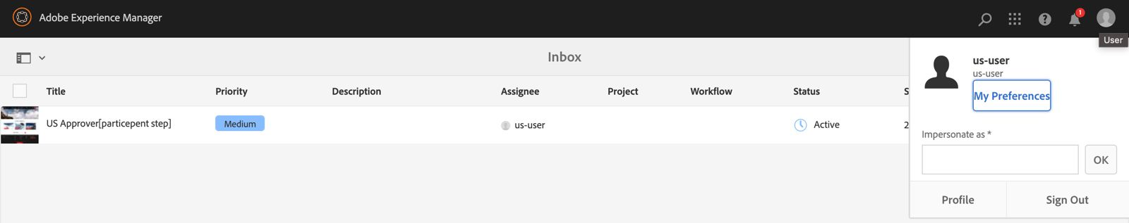

***8🡪If we agree it will go to the second participant step we have to login and complete it ,we will get one popup option in that we have th select UNLOCK PAYLOAD PROCESS step***

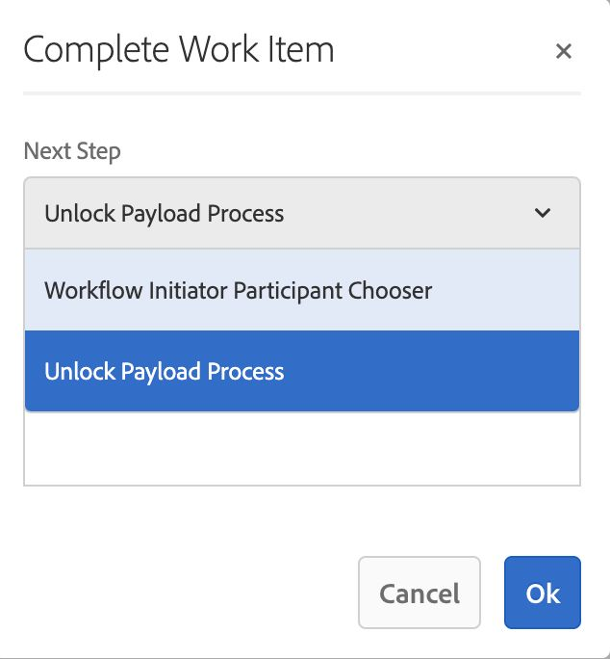

***9🡪Once the workflow unlocked by using "Activate Page/Asset Process” node it will directly publish that page .***

